Name: | Bodhisatya Ghosh
Class: | CSE DS
Batch: | B
UID: | 2021700026
Experiment: | 4

Aim: Read the array of size 10,000,000 . Write the function findlargest(). Compare the time required to perform the given operation using various numbers of threads. Create the table mentioning no of threads and time required. Write down the conclusion.

Code:

#include <stdio.h>
#include <stdlib.h>
#include <pthread.h>

#define ARRAY_SIZE 10000000
// #define NUM_THREADS 4
int array[ARRAY_SIZE];
struct thread_data
{
int thread_id;
int start;
int end;
};
int largest = 0;

void *find_largest(void *thread_arg)
{
struct thread_data *my_data;
my_data = (struct thread_data *) thread_arg;
int start = my_data->start;
int end = my_data->end;
int i;
int local_largest = 0;
for (i = start; i < end; i++)
{
if (array[i] > local_largest)
{
local_largest = array[i];
}
}
if (local_largest > largest)
{
largest = local_largest;
}
pthread_exit(NULL);
}
int findLargest(int arr[],int n)
{
int lower=1, upper = n, count=n;
for(int i=0;i<n;i++)
{
int num=(rand());
arr[i]=num;
}
int largest=arr[0];
for(int i=0;i<n;i++)
{
if(arr[i]>largest)
largest=arr[i];
}
return largest;
}
int main()
{
int *tp=(int *)malloc(sizeof(int)*10000000);
int lower=1, upper = 10000000, count=10000000;
clock_t start, end;
start = clock();
int ans=findLargest(tp,count);
end = clock();
double duration = ((double)end - start)/CLOCKS_PER_SEC;
printf("Largest is: %d and time is: %lf\n",ans,duration);
int i, NUM_THREADS;
printf("\nEnter no.of threads to create: ");
scanf("%d",&NUM_THREADS);
pthread_tthreads[NUM_THREADS];
struct thread_data thread_args[NUM_THREADS];
for (i = 0; i < ARRAY_SIZE; i++)
{
array[i] = rand() % 1000000;
}
for (i = 0; i < NUM_THREADS; i++)
{
thread_args[i].thread_id = i;
thread_args[i].start = i * (ARRAY_SIZE / NUM_THREADS);
thread_args[i].end = (i + 1) * (ARRAY_SIZE / NUM_THREADS);
clock_t start, end;
start = clock();
pthread_create(&threads[i], NULL, find_largest, (void *) &thread_args[i]);
end = clock();
double duration = ((double)end - start)/CLOCKS_PER_SEC;
printf("\ntime taken is: %f\n", duration);
pthread_create(&threads[i], NULL, find_largest, (void *) &thread_args[i]);
}
for (i = 0; i < NUM_THREADS; i++)
{
pthread_join(threads[i], NULL);
}
return 0;
}

Output:
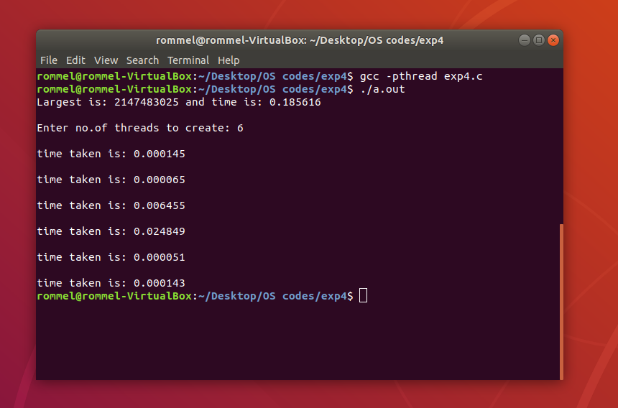
Conclusion: In this experiment, we can see the time teaken for a process is much different when the work is divided uses multithreading

